1. **What was the most impactful thing(s) you learned this week and why do you think so?**

**I really enjoyed learning more about the Flexbox tool. I thought that I was already good at working on it, but in the prove activity I realized that I had to perfect and relearn several properties of said tool. I find that Flexbox can be quite a bit more dynamic in layout than Grid, however, it is more powerful when we use both methods in our layout.**

1. **What questions do you have about this week's chosen topic(s) and/or exercises (first-time students) or websites you are working on (repeat students)?**

**For the col-grid to work I had to add a height of that container as Nefi Perez suggested on Slack. Is there another way to do it without having to apply a height?**

1. **Would you like specific feedback from your instructor? If so, what things would you like feedback on? (Please use the Canvas calendar to schedule time to meet with your instructor or attend a study session.)**

**No, thank you!**

1. **Where would you go next to learn more about this week's topic(s)? Give 2-3 links to resources that look promising to help answer the questions you indicated in the quiz question above.**

* [**https://css-tricks.com/snippets/css/a-guide-to-flexbox/**](https://css-tricks.com/snippets/css/a-guide-to-flexbox/)
* [**https://css-tricks.com/almanac/properties/j/justify-content/**](https://css-tricks.com/almanac/properties/j/justify-content/)

1. **Did you participate with the class on Slack? (You can participate by asking a question, answering a question, or sharing a resource you’ve found. Or you can share your thoughts on what you’re learning this week. Or you can answer any questions your instructor might have given in their announcement.)**

**Yes, I did.**

1. **Please rate your success with learning and this week’s work on a scale of 1 to 4.**

**4**

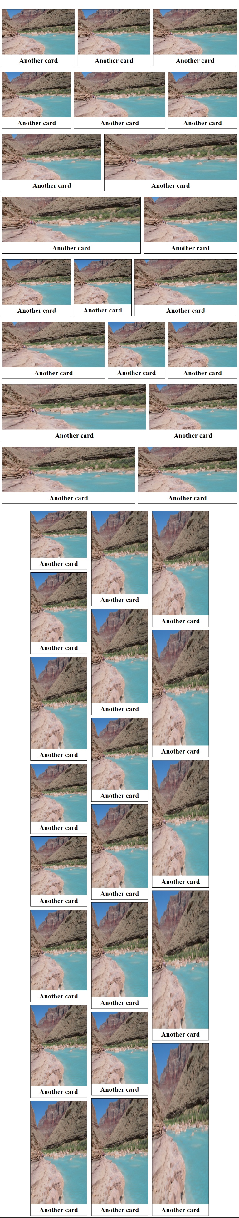**Screenshots:**

row-grid

col-grid

This how the site looks all together:

CSS Code:

.card-grid {

    display: flex;

    flex-direction: column;

    align-items: stretch;

}

.row-grid, .col-grid{

    margin-top: 3%;

}

.card {

    display: flex;

    flex-direction: column;

    border: 1.5px solid black;

    align-items: center;

    flex-grow: 1;

}

.card h2 {

    margin: 7px 0;

}

.row-grid img {

    width: 100%;

    height: 80%;

    object-fit: cover;

}

.row-grid {

    display: flex;

    flex-wrap: wrap;

    justify-content: stretch;

    row-gap: 20px;

    column-gap: 10px;

}

.col-grid {

    display: flex;

    flex-wrap: wrap;

    row-gap: 10px;

    column-gap: 15px;

    flex-direction: column-reverse;

    align-content: center;

    height: 2500px;

}

.col-grid .card {

    flex-shrink: 3;

}

.col-grid img {

    width: 100%;

    height: calc(100% - 30px);

}